**Topics: Confidence Intervals**

1. For each of the following statements, indicate whether it is True/False. If false, explain why.
2. **The sample size of the survey should at least be a fixed percentage of the population size in order to produce representative results.**

A) False : While a larger sample size is generally better for ensuring representative results, it is not a requirement to have a fixed percentage of the population size in the sample.

1. **The sampling frame is a list of every item that appears in a survey sample, including those that did not respond to questions.**

A) False: The sampling frame refers to a list of an item which responds to the question and not the ones which do not respond to the questions.

1. **Larger surveys convey a more accurate impression of the population than smaller surveys.**

A) True: The larger conveys a more accurate impression of the population as larger surveys involve large sample size which reduces the chances of error.

1. ***PC Magazine* asked all of its readers to participate in a survey of their satisfaction with different brands of electronics. In the 2004 survey, which was included in an issue of the magazine that year, more than 9000 readers rated the products on a scale from 1 to 10. The magazine reported that the average rating assigned by 225 readers to a Kodak compact digital camera was 7.5. For this product, identify the following:**
2. **The population**

The population in this context refers to all users or consumers of Kodak compact digital cameras. It includes everyone who could potentially use or purchase this specific product (More than 9000).

1. **The parameter of interest**

The parameter of interest is the average rating assigned by all users or consumers to a Kodak compact digital camera. In this case, the parameter is the average satisfaction rating on a scale from 1 to 10.

1. **The sampling frame**

All PC Magazine readers

1. **The sample size**

The sample size is the number of individuals actually included in the study. In this case, the sample size is 225.

1. **The sampling design**

Random sampling method

1. **Any potential sources of bias or other problems with the survey or sample**

**Selection Bias :** If the survey participants are not representative of all PC Magazine readers or Kodak compact digital camera users, the results may be biased.

**Response bias:** The respondents may not be truthful in their answers. For example, they may be more likely to give a positive rating to a brand they are familiar with, even if they are not actually satisfied with the product.

**Non-Response Bias :** If a significant portion of readers chose not to participate, and their opinions differ from those who participated, it could introduce bias

1. For each of the following statements, indicate whether it is True/False. If false, explain why.
2. **If the 95% confidence interval for the average purchase of customers at a department store is $50 to $110, then $100 is a plausible value for the population mean at this level of confidence.**
3. **TRUE**, The 95% confidence interval is defined as a range of values within which we are 95% confident that the true population mean lies. If the confidence interval includes $100, then this means that $100 is a plausible value for the population mean.
4. **If the 95% confidence interval for the number of moviegoers who purchase concessions is 30% to 45%, this means that fewer than half of all moviegoers purchase concessions.**
5. **FALSE,** The Confidence Interval of 30% to 45% indicates that between 30% and 45% of moviegoers purchase concessions, it doesn't necessarily mean that fewer than half purchase concessions. In fact, a majority of moviegoers could still fall within the 30% to 45% range.
6. **The 95% Confidence-Interval for *μ* only applies if the sample data are nearly normally distributed.**

A) **FALSE,** The 95% confidence interval for the population mean (μ) can be robust to deviations from normality, especially when the sample size is large (typically n ≥ 30). This is due to the Central Limit Theorem

1. **What are the chances that 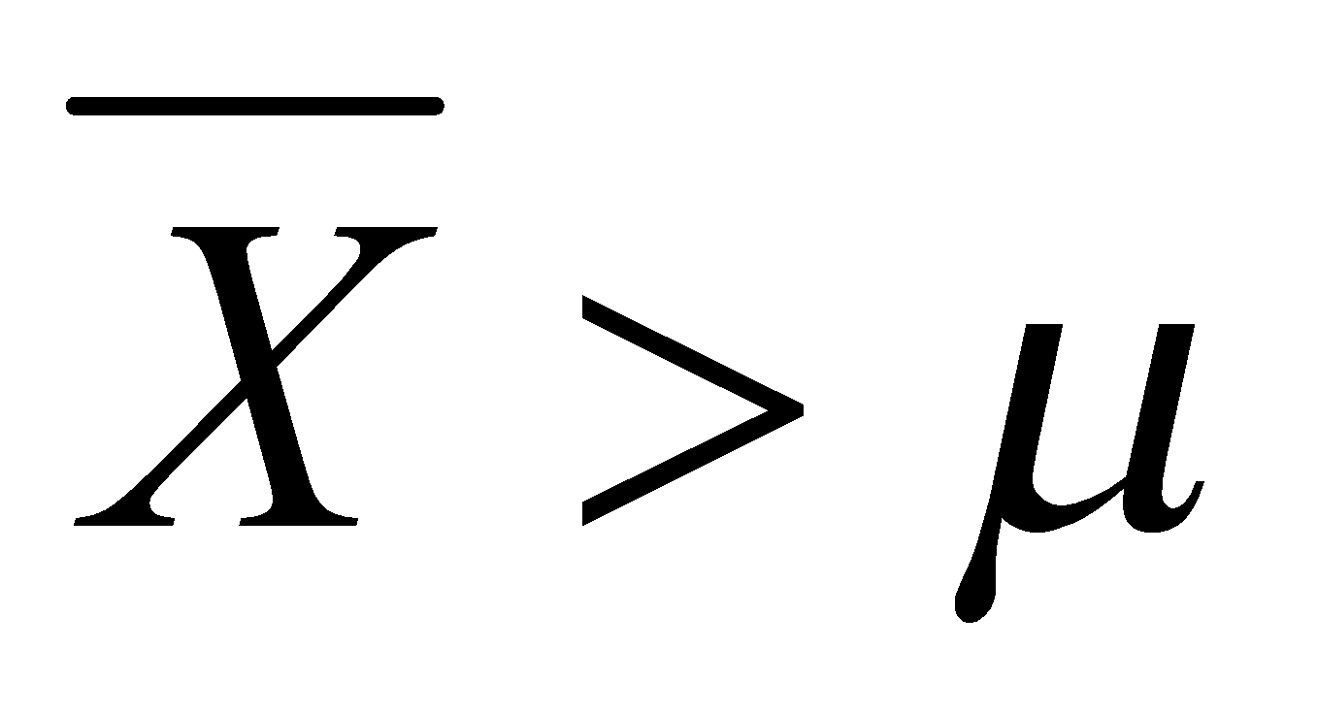?**
2. ¼
3. ½
4. ¾
5. 1

A) If x̄ represents the sample mean and μ is the population mean, the probability that  is 1/2 or 0.5.

**B. ½**

1. **In January 2005, a company that monitors Internet traffic (WebSideStory) reported that its sampling revealed that the Mozilla Firefox browser launched in 2004 had grabbed a 4.6% share of the market.**
2. **If the sample were based on 2,000 users, could Microsoft conclude that Mozilla has a less than 5% share of the market?**
3. Yes, Microsoft can conclude with 95% confidence that Mozilla's market share is less than 5% based on the given sample.
4. **WebSideStory claims that its sample includes all the daily Internet users. If that’s the case, then can Microsoft conclude that Mozilla has a less than 5% share of the market?**
5. Yes, if WebSideStory's claim is true and its sample includes all daily internet users, then Microsoft can conclude that Mozilla has a less than 5% share of the market
6. **A book publisher monitors the size of shipments of its textbooks to university bookstores. For a sample of texts used at various schools, the 95% confidence interval for the size of the shipment was 250 ± 45 books. Which, if any, of the following interpretations of this interval are correct?**
7. **All shipments are between 205 and 295 books.**

Ans: Incorrect. The confidence Interval does not make a definitive statement about all shipments but rather a range within which the true population parameter is likely to fall

1. **95% of shipments are between 205 and 295 books.**

Ans: Incorrect. The confidence interval is about the population parameter (mean), not about individual shipments.

1. **The procedure that produced this interval generates ranges that hold the population mean for 95% of samples.**

Ans: Correct. This is an accurate interpretation. In repeated sampling, 95% of the confidence intervals formed in this way would contain the true population mean.

1. **If we get another sample, then we can be 95% sure that the mean of this second sample is between 205 and 295.**

Ans: Incorret. The 95% confidence interval refers to the population parameter, not the mean of another sample.

1. **We can be 95% confident that the range 160 to 340 holds the population mean.**

Ans: Incorrect. The confidence interval given is 250 ± 45 books, so it is not appropriate to use a different range like 160 to 340.

1. **Which is shorter: a 95% *z*-interval or a 95% *t*-interval for *μ* if we know that σ =s?**
2. **The z-interval is shorter**
3. **The t-interval is shorter**
4. **Both are equal**
5. **We cannot say**

Ans : A. The z-interval is shorter

**Questions 8 and 9 are based on the following: To prepare a report on the economy, analysts need to estimate the percentage of businesses that plan to hire additional employees in the next 60 days.**

1. **How many randomly selected employers (minimum number) must we contact in order to guarantee a margin of error of no more than 4% (at 95% confidence)?**
2. 600
3. 400
4. 550
5. 1000

Ans: **A. 600**

1. **Suppose we want the above margin of error to be based on a 98% confidence level. What sample size (minimum) must we now use?**
2. 1000
3. 757
4. 848
5. 543

Ans: **C. 848**